# Primary Craft Discipline: Q3 How would you describe your primary artistic or creative discipline? (select up to two)

. tab Q3_1, miss

How would you describe your primary |

artistic or creative discipline? |

(select up | Freq. Percent Cum.

------------------------------------+-----------------------------------

Advertising/Branding/Graphic Design | 104 16.17 16.17

. | 539 83.83 100.00

------------------------------------+-----------------------------------

Total | 643 100

. tab Q3_2, miss

How would |

you describe |

your primary |

artistic or |

creative |

discipline? |

(select up | Freq. Percent Cum.

-------------+-----------------------------------

Architecture | 16 2.49 2.49

. | 627 97.51 100.00

-------------+-----------------------------------

Total | 643 100.00

. tab Q3_3, miss

How would |

you |

describe |

your |

primary |

artistic or |

creative |

discipline? |

(select up | Freq. Percent Cum.

------------+-----------------------------------

Coding/UX | 18 2.80 2.80

. | 625 97.20 100.00

------------+-----------------------------------

Total | 643 100.00

. tab Q3_4, miss

How would you describe |

your primary artistic or |

creative discipline? |

(select up | Freq. Percent Cum.

-------------------------+-----------------------------------

Crafting and Textile Art | 39 6.07 6.07

. | 604 93.93 100.00

-------------------------+-----------------------------------

Total | 643 100.00

. tab Q3_5, miss

How would you describe |

your primary artistic or |

creative discipline? |

(select up | Freq. Percent Cum.

-------------------------+-----------------------------------

Event Producers/Managers | 43 6.69 6.69

. | 600 93.31 100.00

-------------------------+-----------------------------------

Total | 643 100.00

. tab Q3_6, miss

How would you describe your primary |

artistic or creative discipline? |

(select up | Freq. Percent Cum.

----------------------------------------+-----------------------------------

Fashion Design (Jewelry and Customizing | 14 2.18 2.18

. | 629 97.82 100.00

----------------------------------------+-----------------------------------

Total | 643 100.00

. tab Q3_7, miss

How would you |

describe your |

primary artistic |

or creative |

discipline? |

(select up | Freq. Percent Cum.

------------------+-----------------------------------

Music/Spoken Word | 74 11.51 11.51

. | 569 88.49 100.00

------------------+-----------------------------------

Total | 643 100.00

. tab Q3_8, miss

How would you describe |

your primary artistic |

or creative discipline? |

(select up | Freq. Percent Cum.

------------------------+-----------------------------------

Photography/Videography | 78 12.13 12.13

. | 565 87.87 100.00

------------------------+-----------------------------------

Total | 643 100.00

. tab Q3_9, miss

How would you describe your |

primary artistic or creative |

discipline? (select up | Freq. Percent Cum.

---------------------------------+-----------------------------------

Stage Performance (Acting/Dance) | 69 10.73 10.73

. | 574 89.27 100.00

---------------------------------+-----------------------------------

Total | 643 100.00

. tab Q3_10, miss

How would you describe your primary |

artistic or creative discipline? |

(select up | Freq. Percent Cum.

----------------------------------------+-----------------------------------

Stagecraft (Sound/Lighting/Construction | 26 4.04 4.04

. | 617 95.96 100.00

----------------------------------------+-----------------------------------

Total | 643 100.00

. tab Q3_11, miss

How would you describe your primary |

artistic or creative discipline? |

(select up | Freq. Percent Cum.

----------------------------------------+-----------------------------------

Visual Artists (Painting/Muralist/Sculp | 222 34.53 34.53

. | 421 65.47 100.00

----------------------------------------+-----------------------------------

Total | 643 100.00

. tab Q3_12, miss

How would |

you |

describe |

your |

primary |

artistic or |

creative |

discipline? |

(select up | Freq. Percent Cum.

------------+-----------------------------------

Woodworking | 8 1.24 1.24

. | 635 98.76 100.00

------------+-----------------------------------

Total | 643 100.00

. tab Q3_13, miss

How would you |

describe your primary |

artistic or creative |

discipline? (select |

up | Freq. Percent Cum.

----------------------+-----------------------------------

Writers/Editors/Poets | 72 11.20 11.20

. | 571 88.80 100.00

----------------------+-----------------------------------

Total | 643 100.00

. tab Q3_14, miss

How would you describe |

your primary artistic |

or creative |

discipline? (select up | Freq. Percent Cum.

-----------------------+-----------------------------------

Other (please explain) | 86 13.37 13.37

. | 557 86.63 100.00

-----------------------+-----------------------------------

Total | 643 100.00

. tab Q3_15, miss

How would you describe |

your primary artistic |

or creative discipline? |

(select up | Freq. Percent Cum.

------------------------+-----------------------------------

Printmaking/Calligraphy | 9 1.40 1.40

. | 634 98.60 100.00

------------------------+-----------------------------------

Total | 643 100.00

## Horizontal bar graph for Craft/art discipline

. graph hbar (count) Q3_1 Q3_2 Q3_3 Q3_4 Q3_5 Q3_6 Q3_7 Q3_8 Q3_9 Q3_10 Q3_11 Q3_12 Q3_13 Q3_15 Q3_14, legend(label( 1 "Advertising/Branding/Graphic Design")) legend(label( 2 "Architecture")) legend(label( 3 "Coding/UX")) legend(label( 4 "Crafting and Textile Art")) legend(label( 5 "Event Producers/Managers")) legend(label( 6 "Fashion Design (Jewelry and Customizing)")) legend(label( 7 "Music/Spoken Word")) legend(label( 8 "Photography/Videography")) legend(label( 9 "Stage Performance (Acting/Dance)")) legend(label( 10 "Stagecraft (Sound/Lighting/Construction)")) legend(label( 11 "Visual Artists (Painting/Muralist/Sculptors)")) legend(label( 12 "Woodworking")) legend(label( 13 "Writers/Editors/Poets")) legend(label( 14 "Printmaking/Calligraphy")) legend(label( 15 "Other"))

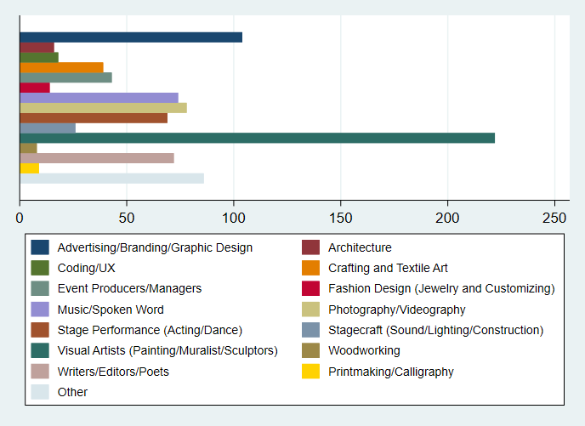

## Descriptive Statistics AFTER recoding: Ethnicity and Race

. tab Q45, miss

Do you identify as |

Hispanic or Latinx? | Freq. Percent Cum.

----------------------+-----------------------------------

Yes | 53 8.24 8.24

No | 428 66.56 74.81

. | 162 25.19 100.00

----------------------+-----------------------------------

Total | 643 100.00

**. *Different Races\***

. tab Q46_1, miss

What is your race? |

(select all that apply) - |

Selected Choice Black or |

African Am | Freq. Percent Cum.

--------------------------+-----------------------------------

Black or African American | 83 12.91 12.91

. | 560 87.09 100.00

--------------------------+-----------------------------------

Total | 643 100.00

. tab Q46_2, miss

What is |

your race? |

(select all |

that apply) |

- Selected |

Choice |

White | Freq. Percent Cum.

------------+-----------------------------------

White | 349 54.28 54.28

. | 294 45.72 100.00

------------+-----------------------------------

Total | 643 100.00

. tab Q46_3, miss

What is your race? (select all |

that apply) - Selected Choice |

American Indian or | Freq. Percent Cum.

----------------------------------+-----------------------------------

American Indian or Alaskan Native | 16 2.49 2.49

. | 627 97.51 100.00

----------------------------------+-----------------------------------

Total | 643 100.00

. tab Q46_4, miss

What is your race? (select all that |

apply) - Selected Choice Native |

Hawaiian or | Freq. Percent Cum.

------------------------------------+-----------------------------------

Native Hawaiian or Pacific Islander | 3 0.47 0.47

. | 640 99.53 100.00

------------------------------------+-----------------------------------

Total | 643 100.00

. tab Q46_5, miss

What is |

your race? |

(select all |

that apply) |

- Selected |

Choice |

Chinese | Freq. Percent Cum.

------------+-----------------------------------

Chinese | 3 0.47 0.47

. | 640 99.53 100.00

------------+-----------------------------------

Total | 643 100.00

. tab Q46_6, miss

What is |

your race? |

(select all |

that apply) |

- Selected |

Choice |

Indian | Freq. Percent Cum.

------------+-----------------------------------

Indian | 14 2.18 2.18

. | 629 97.82 100.00

------------+-----------------------------------

Total | 643 100.00

. tab Q46_7, miss

What is |

your race? |

(select all |

that apply) |

- Selected |

Choice |

Vietnamese | Freq. Percent Cum.

------------+-----------------------------------

Vietnamese | 1 0.16 0.16

. | 642 99.84 100.00

------------+-----------------------------------

Total | 643 100.00

. tab Q46_8, miss

What is your race? (select |

all that apply) - Selected |

Choice Other Asian or Asia | Freq. Percent Cum.

------------------------------+-----------------------------------

Other Asian or Asian American | 16 2.49 2.49

. | 627 97.51 100.00

------------------------------+-----------------------------------

Total | 643 100.00

. tab Q46_9, miss

What is your race? |

(select all that |

apply) - Selected |

Choice Other (please |

speci | Freq. Percent Cum.

-----------------------+-----------------------------------

Other (please specify) | 33 5.13 5.13

. | 610 94.87 100.00

-----------------------+-----------------------------------

Total | 643 100.00

**. *cross tabulation between Hispanic origins and races\***

. tab Q45 Q46_1

| What is

| your race?

| (select

| all that

| apply) -

| Selected

| Choice

| Black or

Do you identify as | African Am

Hispanic or Latinx? | Black or | Total

----------------------+-----------+----------

Yes | 8 | 8

No | 74 | 74

----------------------+-----------+----------

Total | 82 | 82

. tab Q45 Q46_2

| What is

| your race?

| (select

| all that

| apply) -

| Selected

| Choice

Do you identify as | White

Hispanic or Latinx? | White | Total

----------------------+-----------+----------

Yes | 31 | 31

No | 317 | 317

----------------------+-----------+----------

Total | 348 | 348

. tab Q45 Q46_3

| What is

| your race?

| (select

| all that

| apply) -

| Selected

| Choice

| American

Do you identify as | Indian or

Hispanic or Latinx? | American | Total

----------------------+-----------+----------

Yes | 7 | 7

No | 9 | 9

----------------------+-----------+----------

Total | 16 | 16

. tab Q45 Q46_4

| What is

| your race?

| (select

| all that

| apply) -

| Selected

| Choice

| Native

| Hawaiian

Do you identify as | or

Hispanic or Latinx? | Native Ha | Total

----------------------+-----------+----------

Yes | 1 | 1

No | 2 | 2

----------------------+-----------+----------

Total | 3 | 3

. tab Q45 Q46_5

| What is

| your race?

| (select

| all that

| apply) -

| Selected

| Choice

Do you identify as | Chinese

Hispanic or Latinx? | Chinese | Total

----------------------+-----------+----------

Yes | 1 | 1

No | 1 | 1

----------------------+-----------+----------

Total | 2 | 2

. tab Q45 Q46_6

| What is

| your race?

| (select

| all that

| apply) -

| Selected

| Choice

Do you identify as | Indian

Hispanic or Latinx? | Indian | Total

----------------------+-----------+----------

No | 11 | 11

----------------------+-----------+----------

Total | 11 | 11

. tab Q45 Q46_7

| What is

| your race?

| (select

| all that

| apply) -

| Selected

| Choice

Do you identify as | Vietnamese

Hispanic or Latinx? | Vietnames | Total

----------------------+-----------+----------

No | 1 | 1

----------------------+-----------+----------

Total | 1 | 1

. tab Q45 Q46_8

| What is

| your race?

| (select

| all that

| apply) -

| Selected

| Choice

| Other

| Asian or

Do you identify as | Asia

Hispanic or Latinx? | Other Asi | Total

----------------------+-----------+----------

Yes | 2 | 2

No | 12 | 12

----------------------+-----------+----------

Total | 14 | 14

. tab Q45 Q46_9

| What is

| your race?

| (select

| all that

| apply) -

| Selected

| Choice

| Other

| (please

Do you identify as | speci

Hispanic or Latinx? | Other (pl | Total

----------------------+-----------+----------

Yes | 17 | 17

No | 13 | 13

----------------------+-----------+----------

Total | 30 | 30

. tab Q45 Q46_10

no observations

## **Horizontal bar graph for races**

. graph hbar (count) Q46_1 Q46_2 Q46_3 Q46_4 Q46_5 Q46_6 Q46_7 Q46_8 Q46_9 , legend(label( 1 "Black or African American")) legend(label( 2 "White")) legend(label( 3 "American Indian or Alaskan Native")) legend(label( 4 "Native Hawaiian or Pacific Islander")) legend(label( 5 "Chinese")) legend(label( 6 "Indian")) legend(label( 7 "Vietnamese")) legend(label( 8 "Other Asian or Asian American")) legend(label( 9 "Other"))

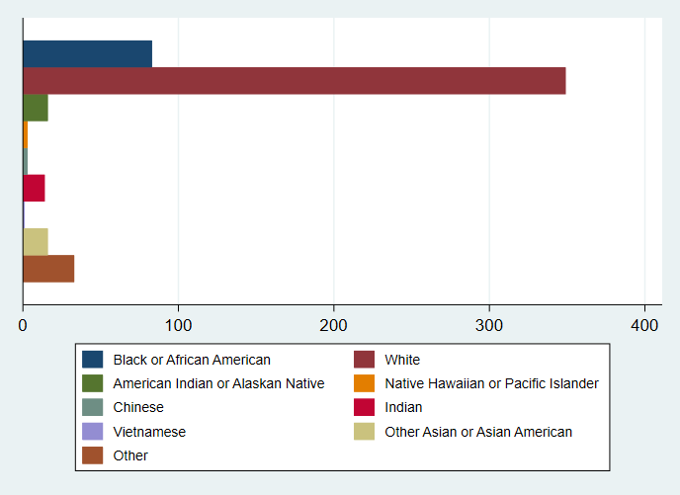

Recoded Race into different single race (binary)variables: White, Black, Native American, Native Hawaiian, Indian, Chinese, Vietnamese, Other_Asian, Other. Native American, Native Hawaiian, Chinese, Vietnamese had less than 5 individuals, hence merged them with Other Race and Other Asian to create two new binary variables: Other_Singular_Race and Other_Asian_Races

Also created Mixed_Race variables(binary): no individual mixed race combination had more than 5 observations.

**\*Horizontal bar graph for singular vs mixed races\***

. graph hbar (mean) White Black Indian Other_Singular_Race Other_Asian_Races Multiple_Race , legend(label( 1 "White Only")) legend(label( 2 "African American/ Black only")) legend(label( 3 "Indian(Asian) only")) legend(label( 4 "Other Singular races")) legend(label( 5 "Other singular Asian races")) legend(label( 6 "Multiple/2 or more races"))

